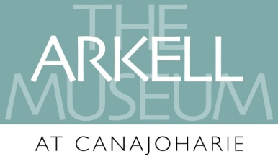
Arkell Museum Junior Docent Program
Junior Docent Requirements:
- Grades 8 – 12 (or ages 14-18)
- Minimum hours: Two 4/hour shifts per month during the school year, and two 4/hour shifts per week during the summer
To Apply:
- Completed application with 2 letters of recommendation from non-family members
- Personal interview
Junior Docents will:
- Act as guides in the museum galleries
- Assist during special events and programs
- Assist staff at off-site outreach opportunities
- Gain a deeper understanding of art, art history, museum education, Mohawk Valley history, and community
Training:
Junior docents will complete ongoing training covering four different stations: the two changing galleries, Night Watch, and the Walkway. The junior docents have the opportunity to interact with visitors of all ages and from around the world, but they with a focus on engaging children and families. At some point during their weekly shift, the “JD” will meet with the Curator of Education to discuss any interesting interactions or problems they encountered, and to receive additional training materials.
Some advantages of participating in this program are:
- Learn new skills and receive on-the-job training
- Become exposed to learning through experiential education
- Improve communication skills and self-esteem
- Make new friends while working in a fun environment
- Learn first-hand about various careers (in art history, exhibit design, education, museums, etc.)
- Have direct interaction with positive role models
- Develop a future recommendation (for jobs, acceptance into other programs, etc.)
- Receive community service credit (e.g., for college applications)
- Make a personal contribution to the community

Junior Docent Program Application
Name:
Address:
Phone: Email:
Birthday: School:
Parent/Guardian Name(s):
Their Phone: Their Email:
Statement of Interest:
Please write a brief statement of interest telling us why you would like to be a Junior Docent. Describe experiences you have that would add to your success as a Junior Docent and what you hope to gain from being a Junior Docent.
References:
References will be contacted to briefly discuss your qualifications to participate in the JD program. Please include the information for two non-family members:
- Name _________________________________________________________
  - Phone ___________________________ Email ________________________
- Name _________________________________________________________
  - Phone ___________________________ Email ________________________
Please submit your application via email (preferred) to Jenna Peterson Riley, Curator of Education & Public Engagement at jriley@arkellmuseum.org with the subject line “Junior Docent Application,” or by mail to 2 Erie Blvd, Canajoharie NY 13317. For more information, please email the above or call 518-673-2314 x 113.

