Instructions on Consignment Sales in Gift Shop
Consignor sales will show up in REVEL as a class on each day’s end of shift slip
(if there was a sale)
In order for the consignor to get paid you must follow these directions:
- If there is a consignor sale you must log onto REVEL back end website to determine what product sold. Go to: https://arkellmuseum.revelup.com. Username : giftshop@arkellmuseum.org password: admin
- Click on Reports tab
- Click on Product Mix
- Choose this week from dropdown menu or most appropriate option
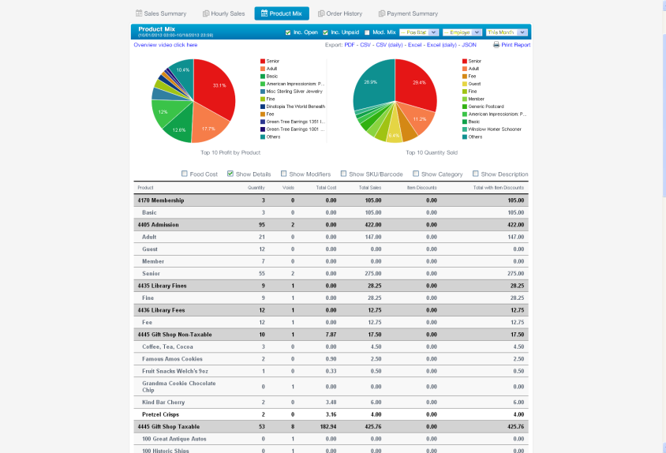
- Check the box Show Details that appears under the pie chart
- You will see the consignors name listed as a Class, look under that to see the name of the item
- Fill out a Consignment Sale form
- Write a check to them for the amount sold less 30%. The QB Class is 530 Gift Shop. Account is 6761.
- Copy form and keep one for our records and mail the other to the consignor along with check.
- Done!

